Project Manual Example: RC Car

This document provides an example of what is expected in a Project Manual. It is not a complete report, and it is only meant to provide an idea of what information is expected, how in depth you need to go, and how your report should be formatted. **Page number recommendations are a guide not a requirement**. Use your own judgement as to how much you need to write to explain your design. Whenever you see ‘...’ it means more writing is expected than what is provided in the example.

# Description

(~1-2pgs, not including block diagram and schematic)

The Description is a high-level overview of what your project is and how it works. Detailed equations and analysis should generally be reserved for the Operation of Building Blocks section. You should provide your Block Diagram and Schematic and ensure they are clear and easy to read. Explain operation of the whole circuit and how the input becomes the output through the building blocks.

This project implements a remote controller and remote control (RC) car. The communication between the controller and the car is implemented with IR emitters and detectors. Commands are encoded in different frequencies. These commands include forward, left, right, and horn. Filters are used to determine which code is being transmitted and activate the corresponding output.

Acronyms should be introduced in parentheses after the word is used the first time as with ‘remote control’ above.

Tables should be labelled as *Table #: Caption*. Tables should appear in the order they are referenced in the text.

*Table I: IR Frequencies and their corresponding command.*

|  |  |
| --- | --- |
| **Frequency** | **Function** |
| 100Hz | Left |
| 707Hz | Forward |
| 5kHz | Right |
| 10kHz | Horn |

The full block diagram for the whole project is shown in Figure 1. There are two separate circuits: the remote and the car control. The remote translates button presses into the corresponding command frequency. The car circuit receives the remote signal and uses filters to activate the corresponding command circuitry. In this Milestone, only the circuitry for the buzzer is implemented: IR sensor, bandpass (BP) filter, Sine-Pulse Width Modulation (PWM) signal converter, and Buzzer.

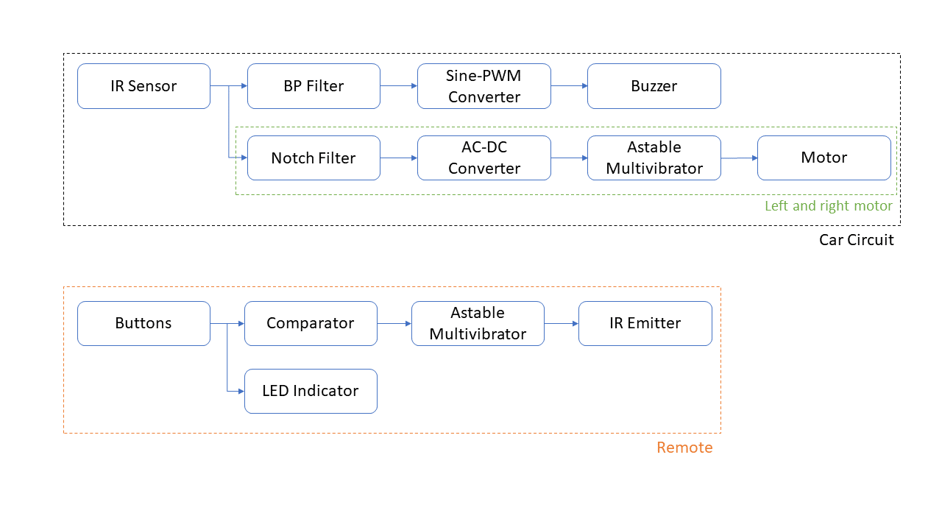

*Figure 1: Block Diagram for project. Note that the Left and Right Motor circuitry is only shown once; two motor circuits exist: one for the left motor and one for the right.*

Figures should be labelled as *Figure #: Caption*. Figures should be appear in the order they are referenced in the text. In Word, you can use References > Cross-Reference to insert an in-text citation of the figure label. Word will automatically update the referenced Figure number if it changes.

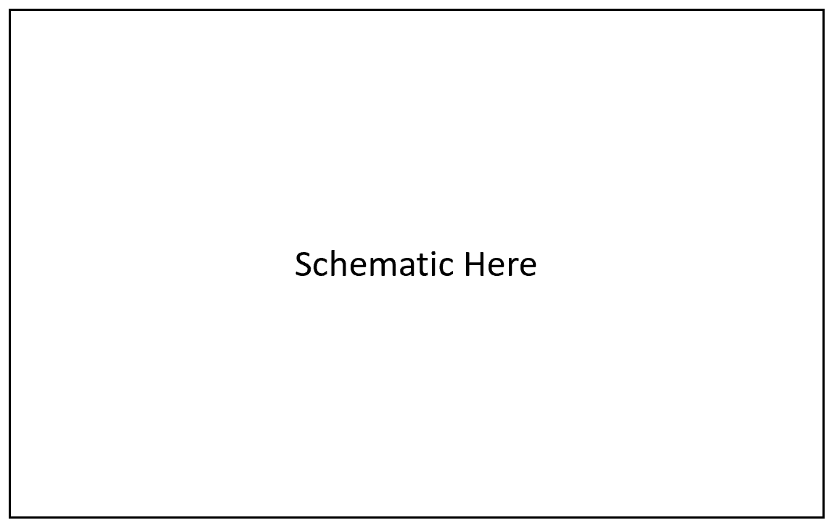

*Figure 2: Schematic of Horn circuit.*

Your schematic should be LARGE and CLEARLY LABELLED. Label any nodes you need to reference in text.

The circuit operates as follows. The IR sensors receives a sinusoidal IR signal and converts this into a sinusoidal voltage of the same frequency. The BP filter allows only signals very close to 10kHz through, so only the 10kHz command will activate the remainder of the circuit. The 10kHz sinusoidal signal will be converted to a 10kHz square wave. This will be sent directly to the buzzer which will produce a 10kHz frequency.

# Operation and Design

(~2pg per building block including figures and equations)

This section should provide a detailed analysis of circuit operation, design choices, and circuit equations. You should have a section for overall circuit operation and a section for each building block.

## Overview

Figure 3 shows an example input and output of the overall circuit. The input (Vin) is measured at the sensor output, and the output (Vout) is measured at the buzzer. The input is a sum of a 500Hz, 10kHz, and 15kHz signal each of 10mV amplitude, which is representative of the output amplitude from the IR sensor. The output shows the 10kHz square wave to be applied to the buzzer.

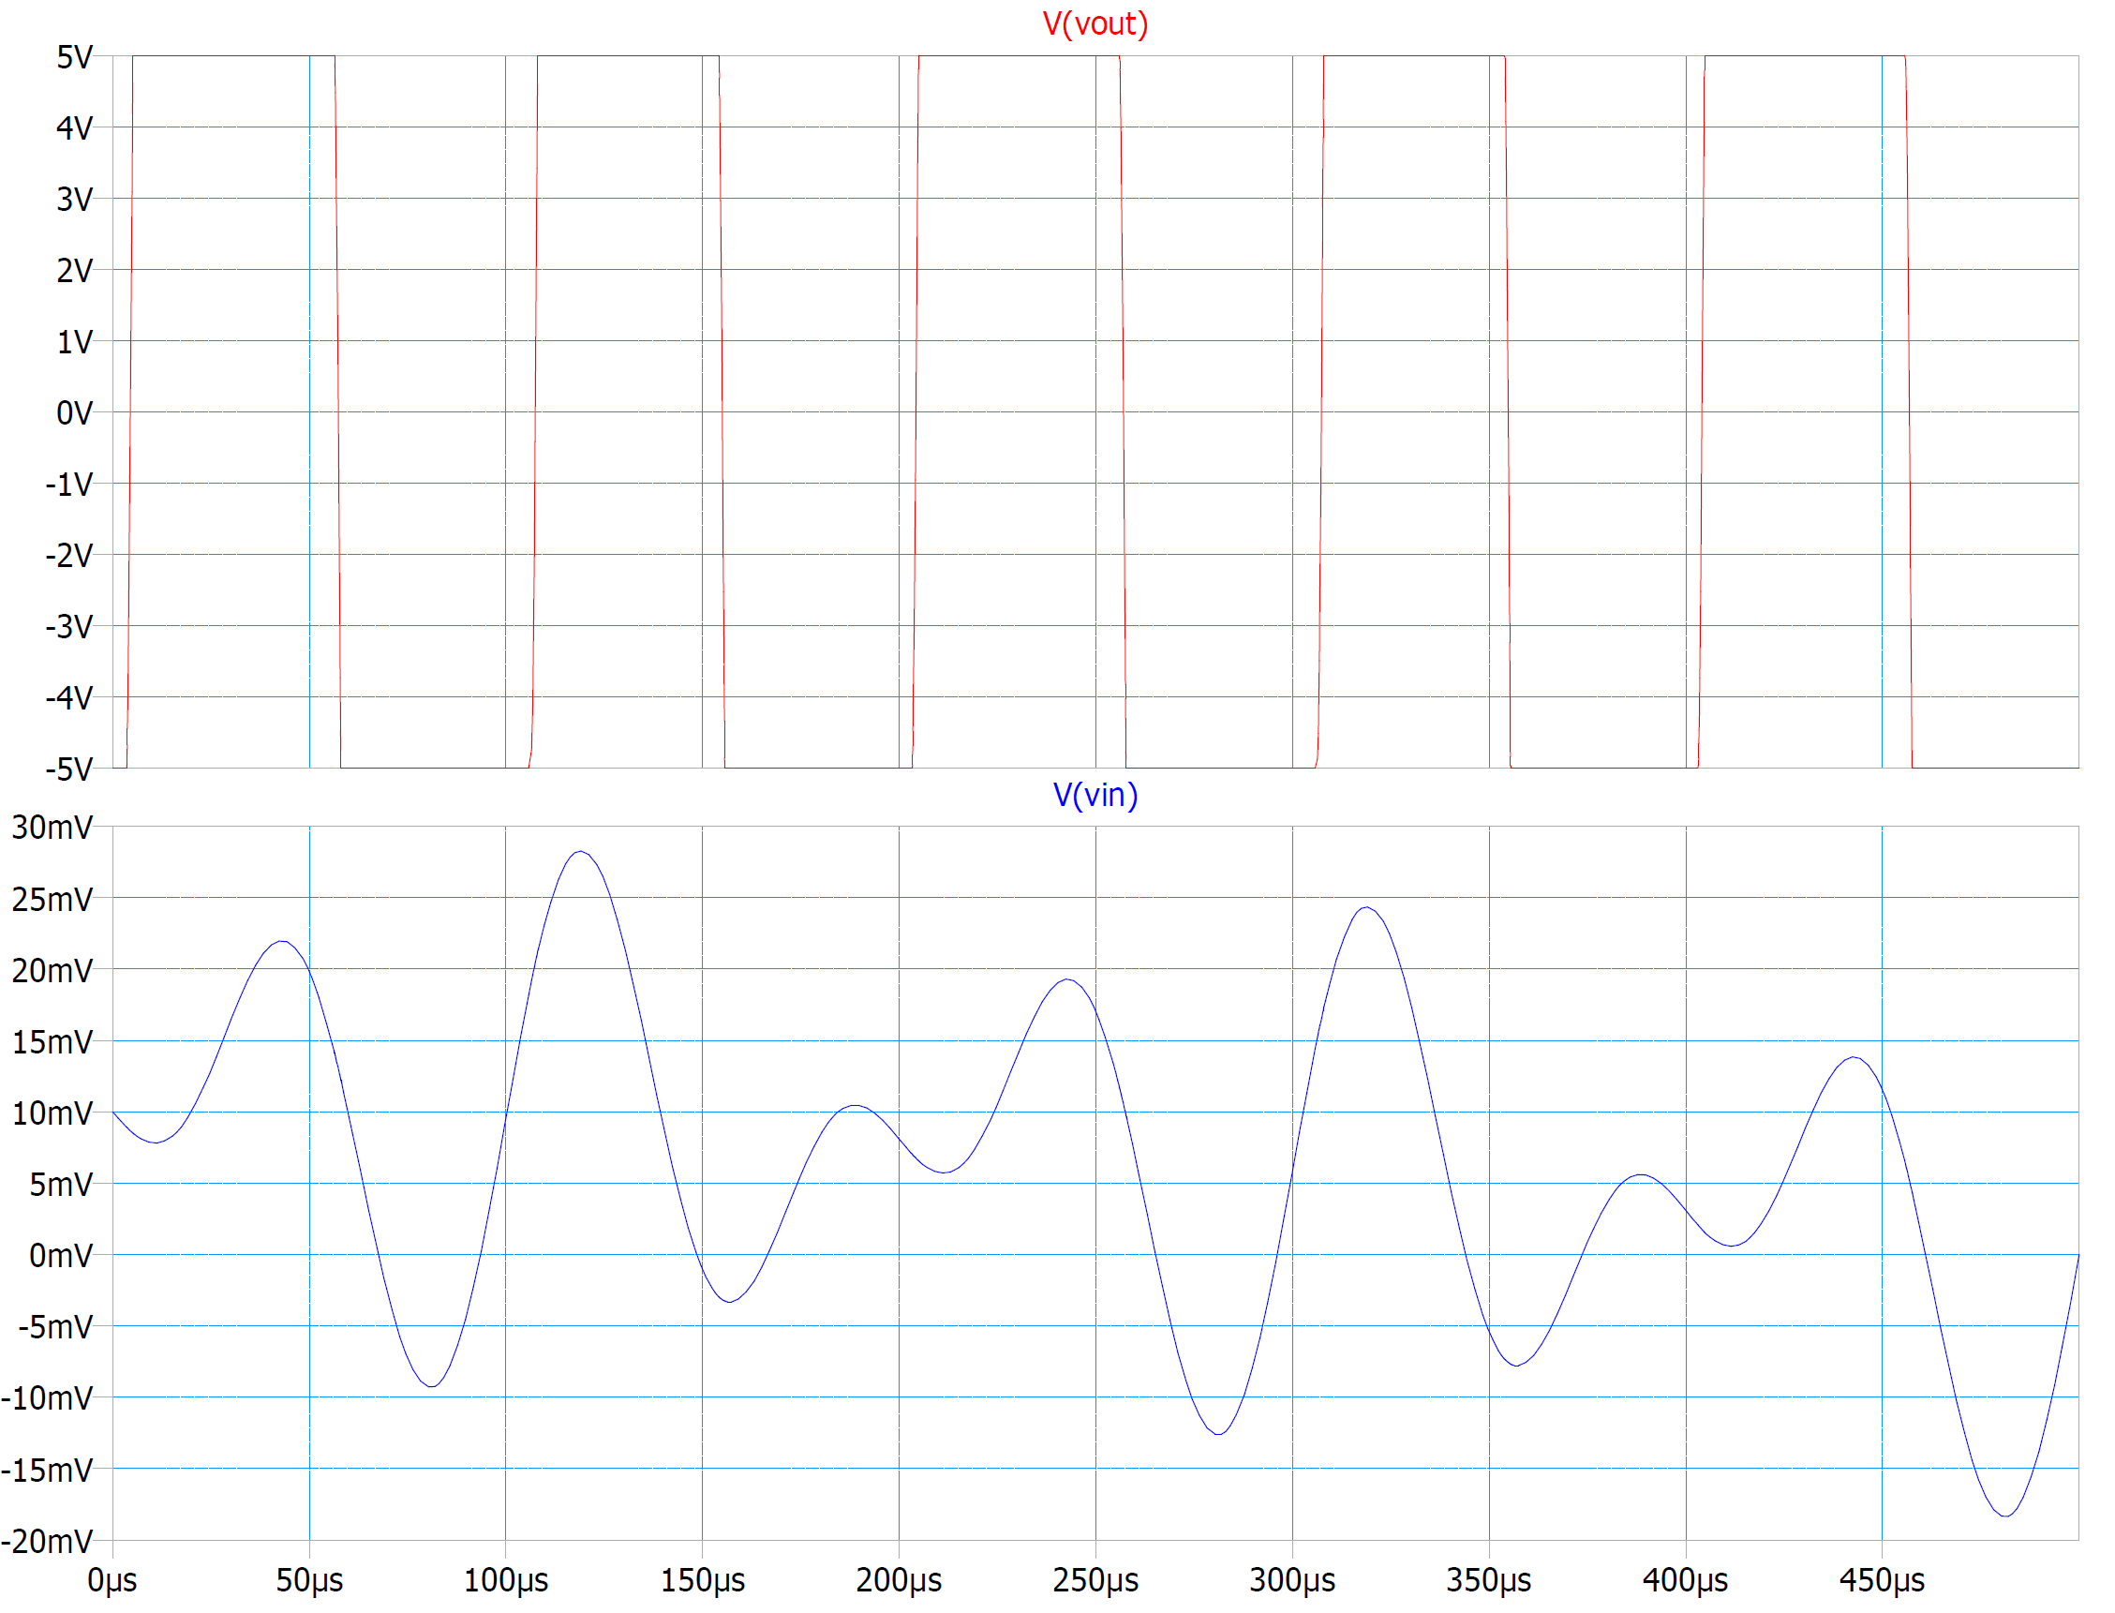

*Figure 3: Example input and output.*

…

## IR Sensor

…

## Bandpass Filter

Building block sections should provide: a labelled schematic, a description of the purpose of the building block in the overall circuit, the equation relating the input to the output, and use of equations to support design decisions.

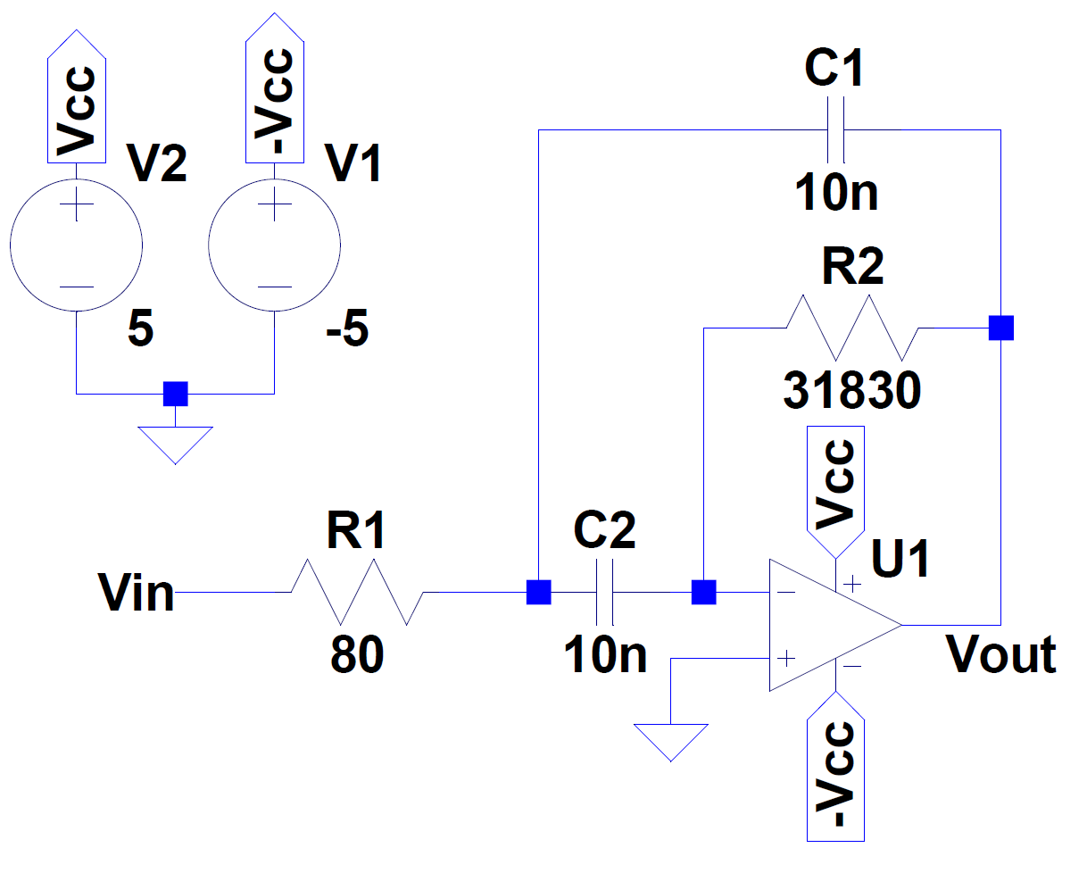

*Figure 4: Second-order bandpass filter, ω0=10kHz, ζ=0.05.*

The IR signal for sounding the car horn (buzzer) is encoded as a 10kHz signal. To filter this specific frequency, a second-order bandpass filter as shown in Figure 1 is used. This filter is chosen because (1) it is an active filter, and (2) it is easy design and build compared to an RLC filter - that is any capacitor value can be chosen and the resistors can be calculated to satisfy the design specifications. Since a range of resistors is readily available, it is easier to find the design components than if the design required a specific inductor or capacitor.

The transfer function for this circuit is:

$T\left(s\right)=\frac{V_{out}\left(s\right)}{V_{in}\left(s\right)}=-\frac{R_{2}C_{2}s}{R_{1}R_{2}C_{1}C_{2}s^{2}+\left(R_{1}C_{1}+R_{1}C_{2}\right)s+1} \#\left(1\right)$

Equations should be labelled with numbers in the format shown above. You can use the Word Equation Editor (Alt+’=’) to easily format and label your equations.

This yield the design equations:

$\sqrt{R_{1}R_{2}C_{1}C_{2}}=\frac{1}{ω_{0}} \#\left(2\right)$

$\sqrt{\frac{R_{1}C_{1}}{R_{2}C_{2}}}+\sqrt{\frac{R_{1}C_{2}}{R_{2}C_{1}}}=2ζ \#\left(3\right)$

In Figure 1, C1=C2, and the design equations become:

$\sqrt{R_{1}R_{2}}C=\frac{1}{ω_{0}} \#\left(4\right)$

$\frac{R_{1}}{R_{2}}=ζ^{2} \#\left(5\right)$

The design requires f0=10kHz with a sufficiently steep roll off such that other signals are filtered out. Thus, ζ=0.05 is chosen. A capacitance of C=10nF is selected, and from Eqn. (4) and (5) R2=31830Ω and R1=80Ω. The simulated Bode plot is shown in Figure 3.

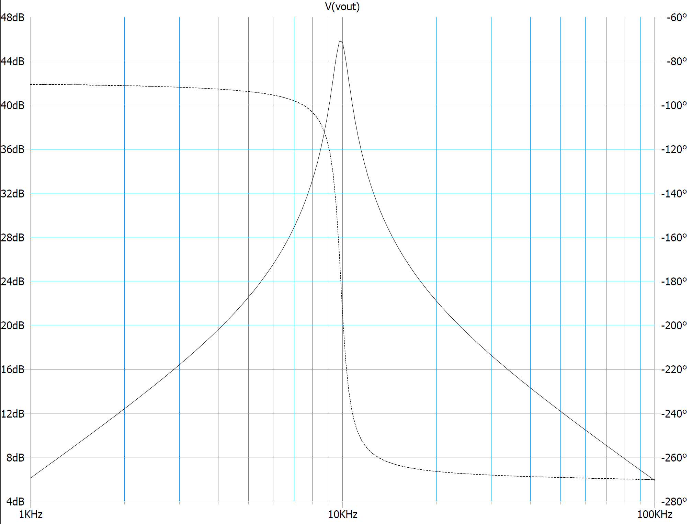

*Figure 5: Bode plot of bandpass filter.*

## Sine-PWM Converter

…

## Buzzer

…

# Operating Conditions

(~1pg, the length of this section as well as the next section depends on what your project is and how far into the project you are. It does not need to be long, but it needs to demonstrate that you have spent some time thinking critically about how your circuit operates, its purpose, and its user.)

This section should describe how the circuit actually functions as you have observed, and situations under which it does not work. This might be operating voltage (is there a maximum or minimum voltage for the circuit to operate properly?), environmental conditions, or hardware ‘bugs’. Describe the limitations of your circuit, explain where these limitations come from, and propose possible solutions (even if you can’t implement them during the course).

The car can only operate in a radius of 15ft due to the IR signal being fairly weak. Furthermore, physical objects obstruct the signal from reaching the target. The operating range of the car is reduced to about 10ft outside in daylight due to light interference. A possible solution to this issue is to use a parabolic reflecting dish with an IR reflective coating to capture diffuse signals on the receiving end.

…

# Applications and Integration

(~1pg)

This section should describe how the reader might go about modifying your circuit for their own purposes or how they might integrate it into their own design. Think about what application your circuit would be used in, or what you wanted to do but didn’t have time for.

To change the buzzer frequency, refer to Eqn. 4. For the buzzer to accept a range of frequencies, the BP filter could be replaced with another BP filter that has a large pass band. This could be implemented with a second-order low pass filter followed by a second-order high pass filter. Ensure that the rolloff of both is sufficiently steep so that there is no interference with other commands or general noise. A good rule is that the amplitude of the BP filter output for a non-horn command should be about 10 times smaller than that of the horn-command. This way it will not be audible.

Additional filters can be added in parallel to create new commands. For example, headlights could be added with a command frequency at 15kHz. When adding filters, keep in mind that each op amp draws a small amount of current and additional isolation between the IR sensor and the filters may be needed to ensure proper operation.

This design could be easily adapted to several other applications that might require remote control. A few applications are: remote control locks, lighting systems, speaker system, and wireless communication of data. Most of these applications require replacing the buzzer with the relevant application output. When doing so, ensure that there is a stage between the BP Filter and the Output to ensure the signal has the appropriate amplitude.